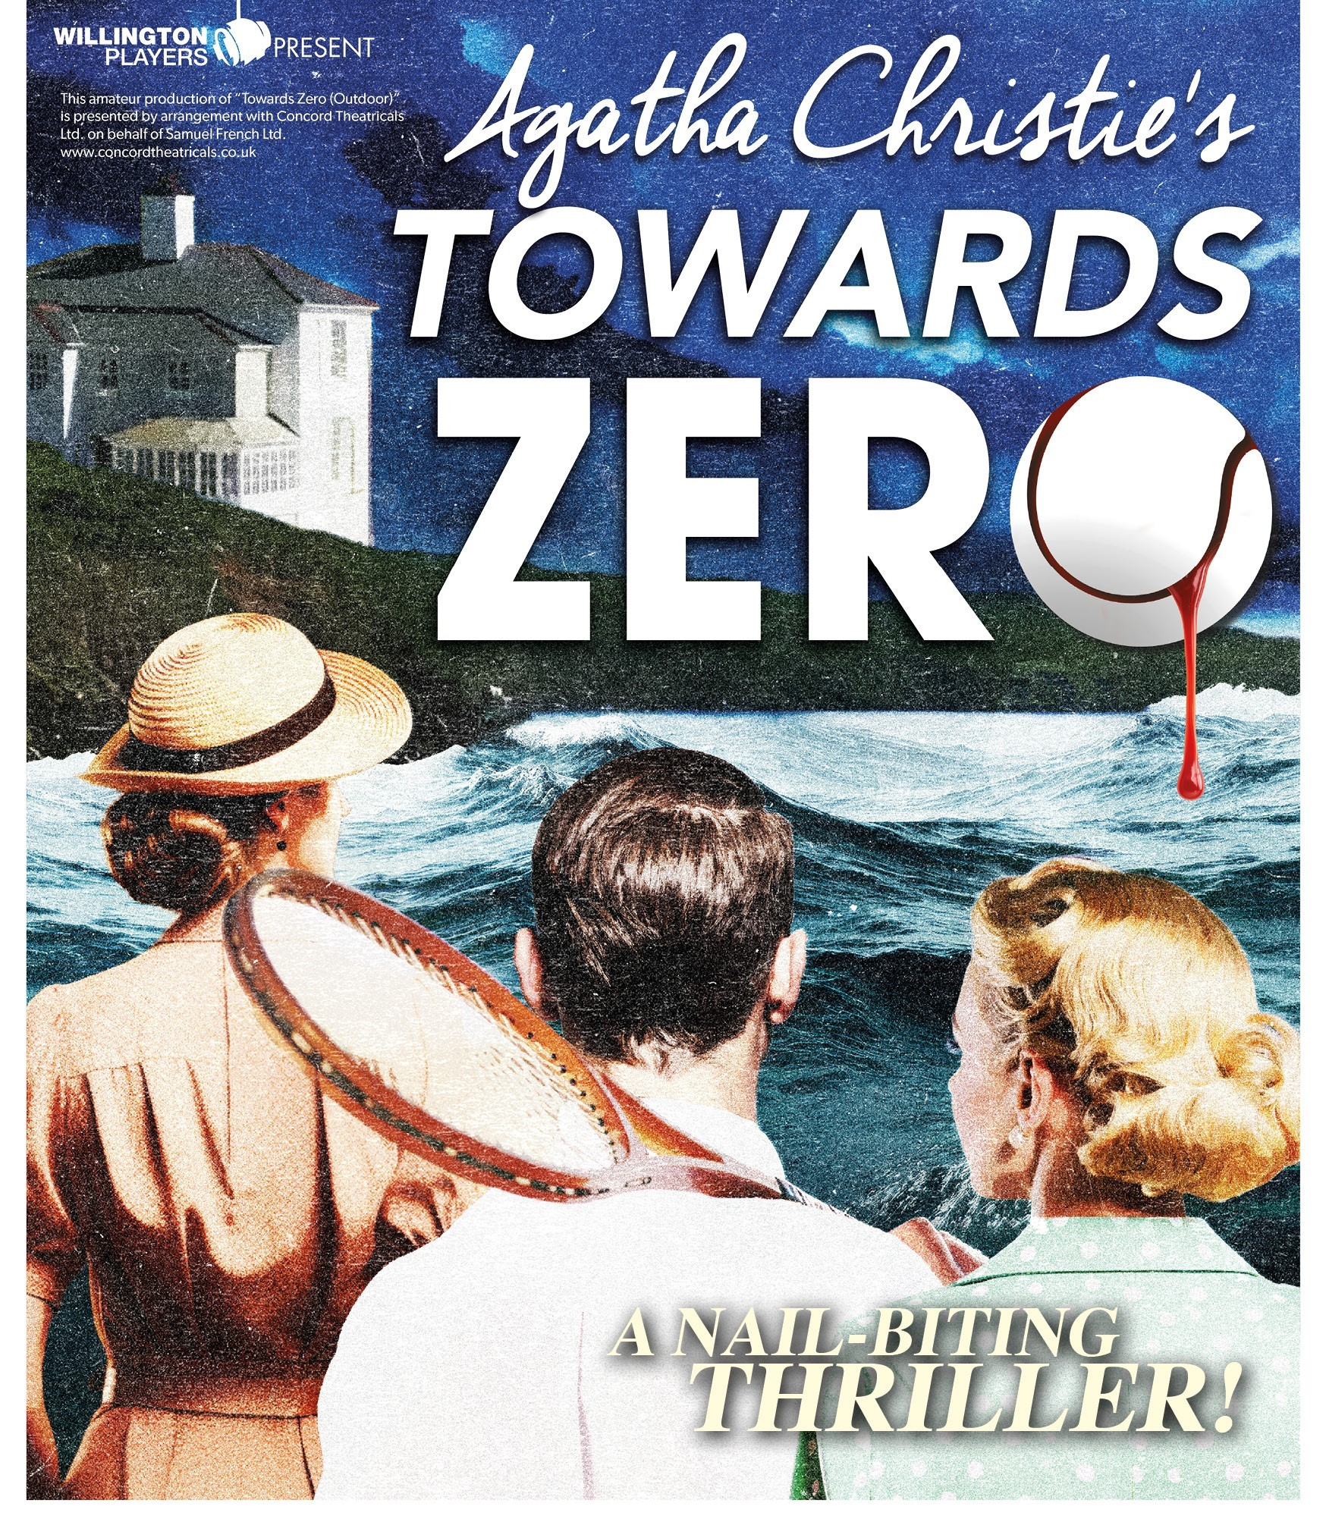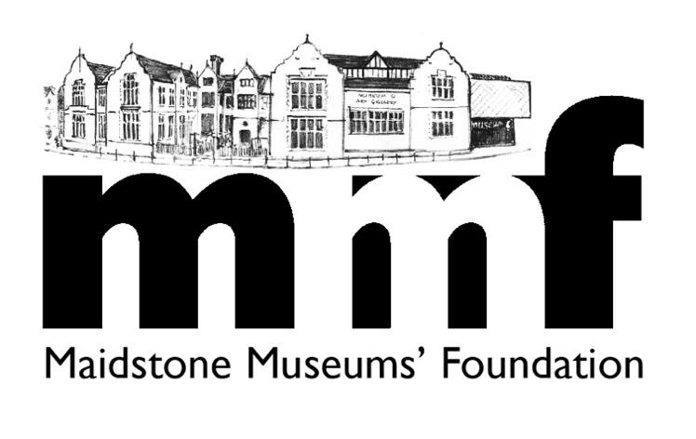

Agatha Christie’s TOWARDS ZERO : ENJOY THIS NAIL-BITING THRILLER! WHILE SUPPORTING MAIDSTONE MUSEUM

HAZLITT THEATRE, MAIDSTONE: TUESDAY April 21st – SATURDAY April 25th 2026 (7.3Opm April 21 – 24; 3PM April 25)

MMF has once again been chosen by the highly regarded Willington Players to benefit from every ticket sold by the charity for their next production Towards Zero.

Agatha Christie’s Towards Zero: When a house party gathers on the terrace of Gull’s Nest, the seaside home of Lady Tressilian, Neville Strange finds himself caught between his old wife , Audrey and his new flame Kay. A nail-biting thriller, the play probes the psychology of jealousy in the shadow of a savage and brutal murder.

For every ticket you buy for £17, MMF receives £7.36. This will go towards a flexible Museum step system now installed but still needing funds. The last play you generously supported Strangers on a Train raised more than £650 for this vital project, an essential improvement to the Lives in our Landscape gallery, opened the summer of 2024 by actor Hugh Dennis. This and the new Oldham Gallery of local history opened last year are well worth a visit.

MMF invites you, your family, friends, and guests to enjoy another entertaining night at the theatre while supporting our museum. You can choose any performance to suit you.

MMF WILL ONLY BENEFIT IF YOU BUY THROUGH MMF – NOT THE THEATRE!

Dining note: By special arrangement with the Willington Players, Frederics Bistro, an MMF corporate supporter, offers a 2-course pre-theatre dinner for £15. This offer is only available by booking directly with the restaurant (01622 297414).

PLEASE ORDER EARLY AS TICKETS ARE LIKELY TO SELL FAST. FINAL ORDERS MUST BE RECEIVED BY MMF NO LATER THAN FRIDAY APRIL 17, 2026.

EASY WAYS TO BOOK

- You can order tickets, with cash or cheque, at the Friends’ Shop in Fremlin Walk (open every Friday and Saturday 10am – 3pm)

- You can email your order to Ivan White at ivangwhite@gmail.com ,stating how many tickets you would like for which performance, giving your name, address and telephone number.

Payment by bank transfer to THE MAIDSTONE MUSEUMS FOUNDATION, 82-61-26, 30117961, using the reference “Your initial + surname + THEATRE”. When the money has been transferred and he has the tickets, they will be posted to you. Or they can be held for collection from the Friends’ shop (opening times above)

- Complete the form below and send with your cheque, payable to Maidstone Museums’ Foundation, to Ivan White at 21 Flaxman Drive Maidstone, ME16 0RU (telephone: 01622 763304).

WILLINGTON PLAYERS: HAZLITT THEATRE
TOWARDS ZERO: APRIL 21 – 25, 2025

NAME……………………………………………………………………

ADDRESS………………………………………………………………..

…………………………………………………………………………….

TEL NO…………………………………..

I/we would like________ticket/s @ £17 each for the performance

on………………………………………………………………………..

PLEASE NOTE THAT EVERY PERFORMANCE EXCEPT SATURDAY STARTS AT 7.30PM, WITH ONLY A MATINEE AT 3PM ON SATURDAY

I/We enclose a cheque for £__________

SIGNED…………………………………………………………..

DATE………………………………………………………………

THANK YOU FOR YOUR SUPPORT. ENJOY THE PLAY!

